Request for Qualifications

3rd Party Construction Testing for New
Cleveland County Justice Center

Cleveland County Justice Center

RFQ-2023 3/9 - rev 1

March 9, 2023

Cleveland County Administrative Building
Attn: Blake Myers
Finance & Purchasing Department
311 E. Marion St
Shelby, NC 28150
Office: 704-484-4778
Email: Blake.Myers@ClevelandCountync.gov

3rd Party Testing Services
Cleveland County Justice Center

Table of Contents
1. Introduction 3
2. Overview 4
3. General Requirements 4
4. Firm’s Affirmations 5
5. Submission Requirements 6
6. Terms and Conditions 6
7. Scope of Work 6
8. Included in Qualifications: 7
9. RFQ Form 10

- Introduction
Cleveland County Government is requesting qualifications of licensed general contracting firms to provide specified professional services in connection with the new Cleveland County Justice Center 3rd Party Testing Requirements.

The submittal deadline is 3-27-2023

The firm’s qualification package shall be submitted as an electronic PDF on a USB thumb drive, and in 3 paper copies in a sealed envelope/box.
The envelope/box shall be labeled with the project name and the firm’s name.
Qualification packages can be submitted by any one of the following methods:

Mail: Cleveland County
Finance & Purchasing Department
Attn: Tonya Brittain
PO Box 1210
Shelby, NC 28151

Hand delivered: Cleveland County Administrative Building
2nd Floor
Finance & Purchasing Department
Attn: Tonya Brittain
311 E. Marion St
Shelby, NC
Administrative questions can be emailed to Tonya Brittain at: Tonya.Brittain@clevelandcountync.gov

Any project scope questions should be emailed to: Blake.Myers@clevelandcountync.gov no later than 3-20-2023

- Overview
Cleveland County will be building a new justice center “Courthouse, Sheriff’s Office, and Detention center” with an estimated ground breaking of April/May of 2023 and is expected to complete this project in the last quarter of 2025 or first quarter of 2026. Cleveland County is looking to hire a firm for all the 3rd party testing needs during the course of the project. Included but not limited to- Concrete slump, footings, ground compaction, etc.
The full and complete scope of this project will be completed in collaboration with both county officials, City inspectors, and Yates/Metcon (CMAR).

The anticipated fees for this type of project should be based on similar sized projects with similar requirements. The final budget will be decided once a full list of 3rd party testing needs has been completed after all final design drawings have been issued.

The Cleveland County Justice Center Team will choose a qualified firm using a two-step process—select firms qualified to provide such services on the basis of demonstrated competence and qualifications and an interview meeting where the firm presents their proposal and team.

The Justice Center Team will rate the firm based on, but not limited to, the criteria below:

- Overall reputation of the firm/team
- Key team members — experience and qualifications
- Project references specific to this type of service
- Experience with applicable regulatory agencies and permitting.
- Experience with providing these services to local governments.
- General project understanding and approach of 3rd party testing for new construction purposes.
- 3rd party testing of similar projects.
- Proposed fees/general cost analysis.
- Unique qualities that would make firm/team best suited for the project.
- Proposed team members.

Cleveland County will use the standard AIA Document B101TM—2017 for the basis of the contract agreement with a terms and conditions addendum as needed.
- General Requirements
  - The RFQ contact form must be signed and returned with firm’s proposal package for the services and deliverables described in Schedule 7 (the “Scope of Work”).
  - The County will not be bound to act by any communication or proposal submitted by firms other than in accordance with this RFQ.
  - Firm’s questions and the County’s responses may or may not be forwarded to all firms. The County reserves the right to communicate all or part of the questions and responses, with all, or certain firms.
  - By submitting a proposal package in response to this RFQ, firm is deemed to accept the award selection process and criteria and County’s discretion in connection with such process and criteria.
  - By submitting a proposal package in response to this RFQ, the firm acknowledges and waives any claim for compensation of any kind whatsoever against the County or any of its Representatives (as defined below), as a result of its submission, any decision made by the County during the RFQ process, including when acting in its sole discretion, or arising in any other manner from its participation in this RFQ.
- Firm’s Affirmations
  - By submitting its qualifications, the firm represents and warrants the following:
    - This RFQ is a solicitation for professional proposals and is not a contract or an offer to contract.
    - The submission of a proposal package by the firm in response to this RFQ will not create a contract between the County and firm.
  - The County makes no representation or warranty, written or oral, that one or more contracts will be awarded under this RFQ; and
  - The firm will bear, as its sole risk and responsibility, any cost arising from firm’s preparation of a response to this RFQ and, as applicable, contract negotiations.
  - The firm is a reputable person that is lawfully and regularly engaged in providing and/or performing the Professional Services.
  - The firm has the necessary experience, knowledge, abilities, skills, and resources to provide the Deliverables and/or perform the Professional Services upon the terms and conditions specified in this RFQ.
  - The firm is aware of, is fully informed about, and is in full compliance with all applicable federal, state and local laws, rules, regulations and ordinances including, without limitation, those relating to bid rigging.
  - The firm understands:
    - The requirements and specifications set forth in this RFQ and
    - The terms and conditions set forth under which the firm will be required to operate.
  - If selected by the County, the firm will not delegate any of its duties or responsibilities under this RFQ or any resulting contract to any subcontractor, except as expressly provided in the qualifications.
  - If selected by the County, the firm will maintain any insurance coverage required by the contract during the term thereof.
  - All statements, information and representations prepared and submitted in response to this RFQ are current, complete, true and accurate. The firm acknowledges that the County will rely on such statements, information and representations in selecting the successful professional services provider. If selected by the County, the firm will notify the County immediately of any material change in any matters regarding the firm’s responses to questions asked by the county, any documentation the firm has provided or any change that would materially impact the firm’s ability to execute and complete the project as agreed upon.
  - The firm has not given or offered to give to the County or any of its Representatives nor does it intend to give at any time hereafter, any economic opportunity, future employment, gift, loan, gratuity, special discount, trip, favor or service in connection with its submitted quotation.
  - The firm certifies that other than the relationships which have been previously disclosed to the County in writing:
    - No relationship, whether by blood, marriage, business association, capital funding agreement or any other such kinship or connection exists between the owner of any firm that is a sole proprietorship, the officers or directors of any firm that is a corporation, the partners of any firm that is a partnership, the joint ventures of any firm that is a joint venture or the members or managers of any firm that is a limited liability company, on one hand, and an employee of any affiliate of the County, on the other hand, and
    - The firm or any of its officers, directors and shareholders/partners has not been an employee of the County within the immediate twelve (12) months prior to the submittal deadline of this RFQ. All disclosures by firm in connection with this certification will be subject to administrative review and approval before the County enters into a purchase order, contract or agreement with firm.
  - The firm represents and warrants that no proceedings have been taken or authorized by it or by any other person with respect to the bankruptcy, insolvency, liquidation, dissolution or winding up of the firm nor, to the knowledge of the firm, has anyone threaten to take any such proceedings against it.
- Submission Requirements
  - Contact: All completed documents constituting your proposal, as well as any questions or clarifications concerning this RFQ must be submitted to the County’s representative identified on page 3 of this RFQ.
  - Timeline: The proposal package must be received on or before the submittal deadline (date and time) specified on page 3 of this RFQ. The County reserves the right, but has no obligation, to accept a qualification package submitted after the deadline and to amend the timeline. If a change to the timeline is required, the County will communicate the change to the firm(s). If a firm requests an extension of a deadline, the County may, in its sole discretion, decide to allow the extension or not. The County may, in its sole discretion, decide whether or not to communicate to the other firm(s) it granting of an extension or to offer them with the same extension.
- Terms and Conditions
  - Contract—at a later date using AIA Document B101TM—2017
  - Office Locations—The firm must state the office location it plans to use.
  - Terms and Conditions—at a later date using AIA Document B101TM—2017 with an addendum.
- Scope of Work
  - Complete 3rd party testing during construction of new Justice Center.
a. 3rd party testing for any and all required testing needs. Final design for testing requirements will be finalized after drawings have been completed. Firm is expected to work with all parties to outline testing requirements.
b. Firm will be expected to be on site upon request of CMAR contractors Yates/Metcon and any subcontractor that may require a 3rd party inspection in order to continue working/placing materials.
c. Firm will be responsible for any scheduled 3rd party testing that is NOT completed in which cost the county or the CMAR contractor money/time due to schedule or crew impacts.
d. Firm will be required to keep and maintain all records of testing outcomes and data in which will be turned over the county on a monthly basis. The firm will also be required to submit a final report at the end of the project with a log of all testing and outcomes throughout the overall course of the project.
e. Firm will be required to submit monthly log reports as part of back up during the billing cycle. Firm will be required to submit billings once per month with any/all backup for each billing cycle.

- Included in Qualifications:
  - List of recent applicable facility projects with:
    - A brief description of firm’s role.
    - Pictures or 3-D renderings of any applicable projects.
    - Three to five client references and contact information.
  - Construction Project organization
    - Team organization chart with names and functions.
    - List of team members resumes and relative work experience.
    - Proposed project execution plan/schedule.
  - Cost of Services
    - Estimated Cost of 3rd party testing break out/backup.
    - Explanation of estimated 3rd party cost break out and lump sum.
    - List of any alternate or optional services (including costs broken out from project total).
    - Miscellaneous.

Appendix

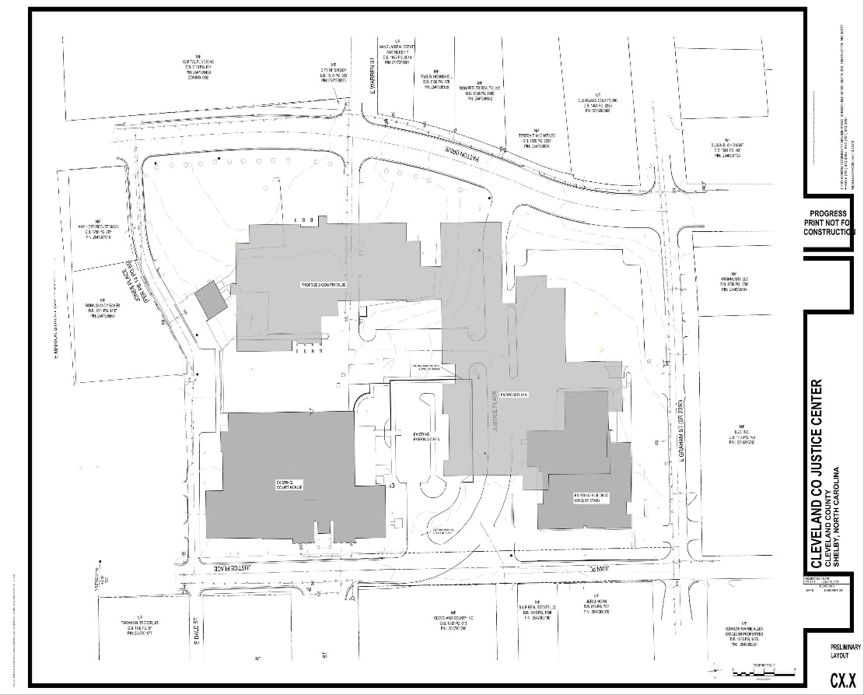
Project Site layout

THIS IS AN ESTIMATED SITE PLAN. DRIVEWAYS AND PARKING COULD CHANGE DEPENDING ON DESIGN.

- RFQ Form
To: Cleveland County Finance & Purchasing Department
PO Box 1210
ATTN: Tonya Brittain
311 E. Marion Street
Shelby, NC 28151

From: _________________________________ Date: _______________________
_________________________________
_________________________________
_________________________________

Principal Contact Information

__________________________________
Signature

___________________________________
Print Name

___________________________________
License Number

___________________________________
Expiration Date

___________________________________
Company Name
___________________________________
Company Address Line 1

___________________________________
Company Address Line 2

___________________________________
Work Phone

___________________________________
Cell Phone

___________________________________
Email

